PEI DIS Training Guide Manual:
Using web browser, navigate to: http://icsprodweb/pp/default.php
To logon to the DIS, enter username and password and click Logon.
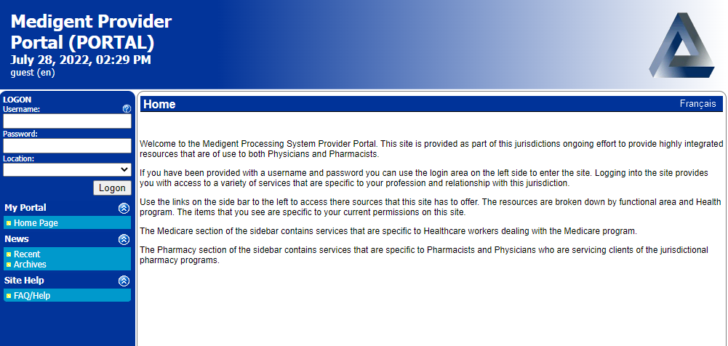
**Note: if the password entered is incorrect three times in a row, the account will lock. Contact the IT department at (902) 620-3600 in order to regain access.
DIS access through the Medigent Provider Portal is only accessible through the government internet network
For technical issues, including password and username issues, please contact Service Centre

Once successfully logged into the DIS, page will redirect to Client Lookup.
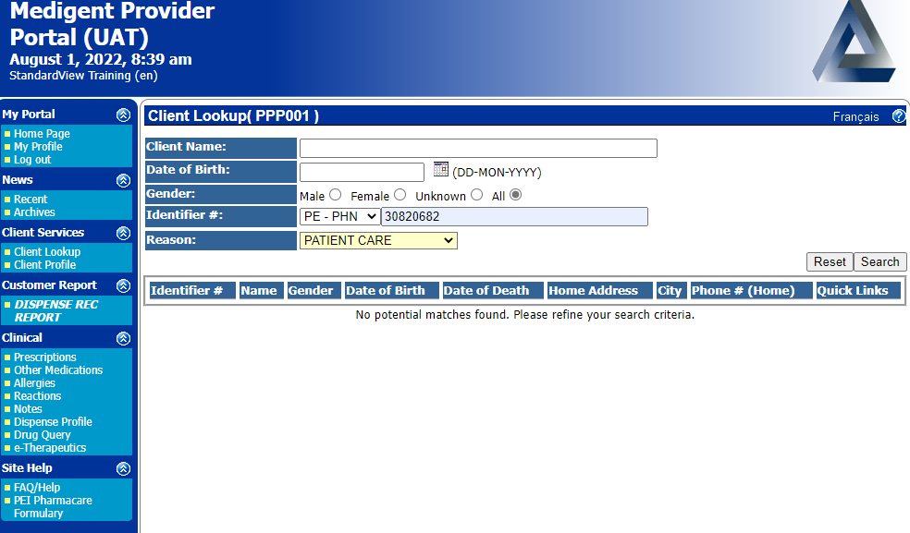
Client Name or Identifier Number (PE -PHN) should be used when completing a search. In addition, date of birth and gender are options to use in order to narrow the search:
- Client’s Name: surname, first name, middle name.

- Date of birth : day, month, year

- Identifier # (PE PHN ): 8 digit health card number

- Reason: choose from the drop down list provided.

- Note** Fields with the * are required to complete the request.

Only patients with a valid PEI Health Card can be searched.

- Client Profile Page:
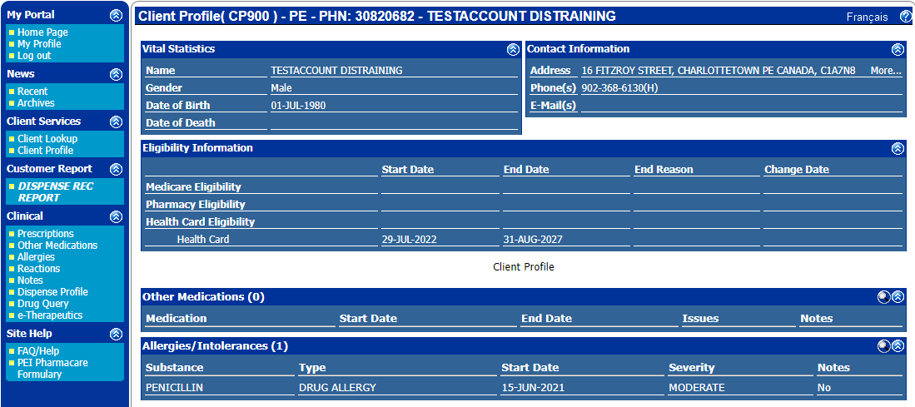
Standard information available:
- Name
- Gender
- Date of birth
- Address
- Phone number
- Allergies and intolerances
- Other medications
Eligibility Information:
- Health card status: start and end date, end reason

- Dispense Rec Report:

The Dispense Rec Report contains information about medication(s) dispensed to a client from community pharmacies.
Note: DIS does not capture or track any medications dispensed from a hospital admission.
The dispense rec report can be an aid in identifying prescribed medications, but is not a complete record as it does not track over the counter medications, vitamins or minerals the client may be taking as well.
Dispense Rec Report only contains information related to prescription medications filled at a PEI community pharmacy.

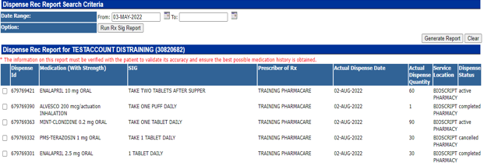
The dispense rec report contains all basic information about a prescription:
- Date Range – The date range can be adjusted and generally should be modified to include at least 6 months of dispense history to review for BPMH.

- Dispense ID – DIS interaction identification number – hyperlink provides additional information

- Medication (with Strength)

- SIG – Instructions on how medication is taken according to physician

- Prescriber of Rx

- Actual Dispense Date - Refers to the day that the pharmacy actioned (filled, logged or cancelled) the script. This does not mean the date the patient picked up or started taking the medication.

- Service Location – Pharmacy location

- Dispense Status:
-Active: the prescription has been filled by the community pharmacy but has not been picked up by the client
-Completed: the prescription has been filled and picked up by the client
-Cancelled: the client is not receiving this prescription from the community pharmacy
Clicking on the column headings will reorganize each list. For example, select “Medication (With Strength)” to reorganize medication names into alphabetical order.
Filter page by date, at the top of screen, to narrow a search to a specific date range.
When you are on this page,
- Generate the report
- Print to PDF
  - This will download the report when you can view and print to a hard copy
- Dispense Profile (Summary report):
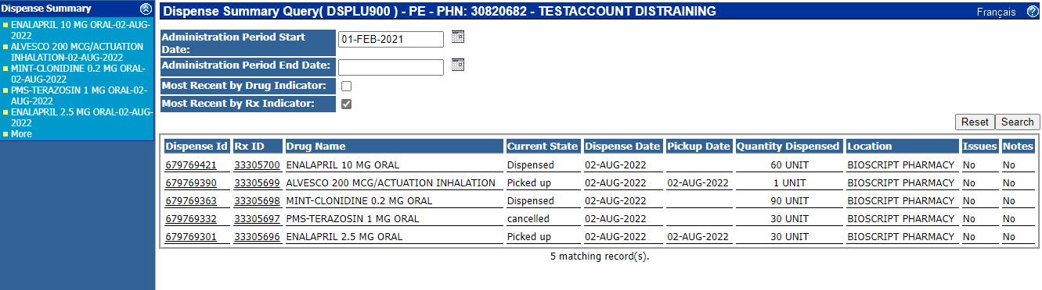
The dispense profile contains basic information about a prescription such as the name, strength and formulation of the medication, the date the medication was dispensed and picked up, the quantity dispensed and the location where it was dispensed.

Current state of the prescription is also included and is one of three options:
- Dispensed: the prescription is filled but not picked up
- Picked up: the prescription was filled and picked up by the client
- Cancelled: the prescription is not being filled for the client
Filter page by date, at the top of screen, to narrow a search to a specific date range.

Use column headings to reorganize each list. For example, select “Drug Name” to reorganize medication names into alphabetical order.

Select the dispense ID or medication name in the left hand corner to view additional details about a prescription.

The difference between the Dispense Rec Report and the Dispense Summary Report is that the Dispense Summary Report shows the pickup date of the medication from the pharmacy, and any documented notes about this interaction at the Pharmacy level whereas the dispense rec report does not.

- Prescriptions:
Users have an option to view existing prescriptions from across the province on the client’s profile. This helps track which pharmacies the client uses.

- Other medications
Other medications included within the DIS include over the counter medication (OTC) and samples from a doctor’s office reported by the client, and recorded at the pharmacy level.
Users have an option to view existing other medications on a client’s profile.
“Other Medications” only includes medications manually entered by other healthcare providers and should NOT be considered an exhaustive list.

- Allergies
Users have an option to view existing allergies documented on a client’s profile.
“Allergies” only includes those entered by healthcare providers. The allergies found on DIS:
  - should NOT be considered an exhaustive list
  - do NOT mirror allergies listed in Cerner (CIS), CHR/EMR or other sources.

Note: It is important to keep in mind that only allergens with a DIN or NPN can added to this allergy list.

- Reactions
Users have an option to view existing reactions documented within a client’s profile.

- Notes:
Users have an option to view existing documented notes within the client profile.

- Drug Query
Users have access to drug monographs through searching with the drug query.

To search for a drug monograph, enter the drug code or name of the drug. Manufacturer name is optional.
Once search is complete, select appropriate drug code read its monograph.
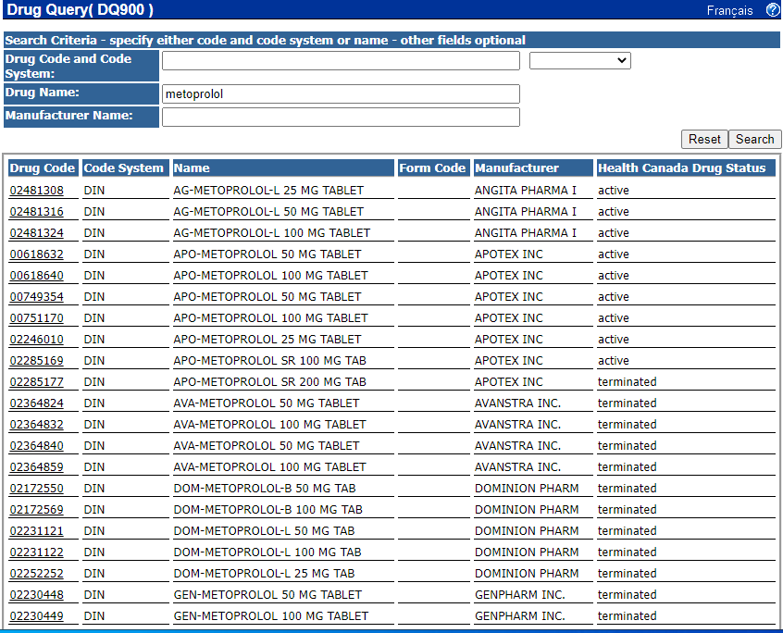

A drug monograph provides information about medication use, side effects, precautions, interactions and more.
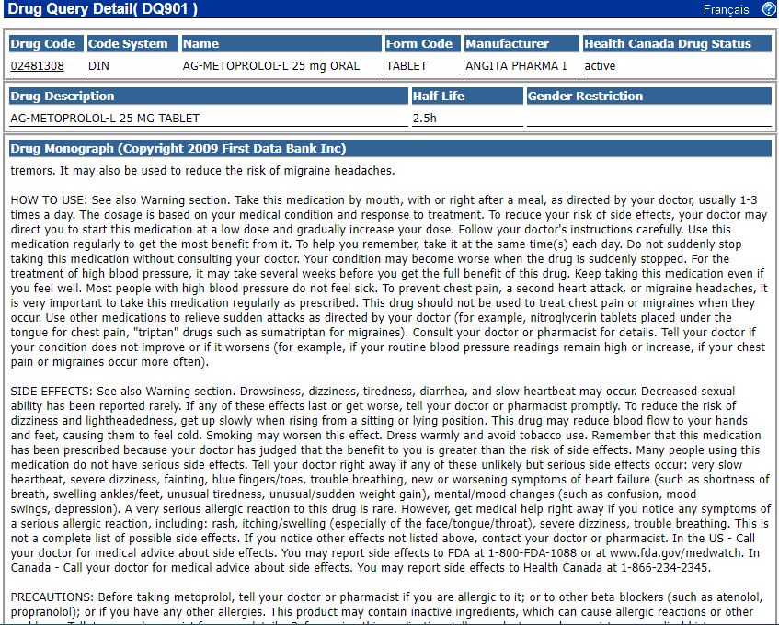

How to change my password?
“My Profile” function contains basic account information.
Edit personal DIS information such as display name, email and password, without having to use ITSS services here.
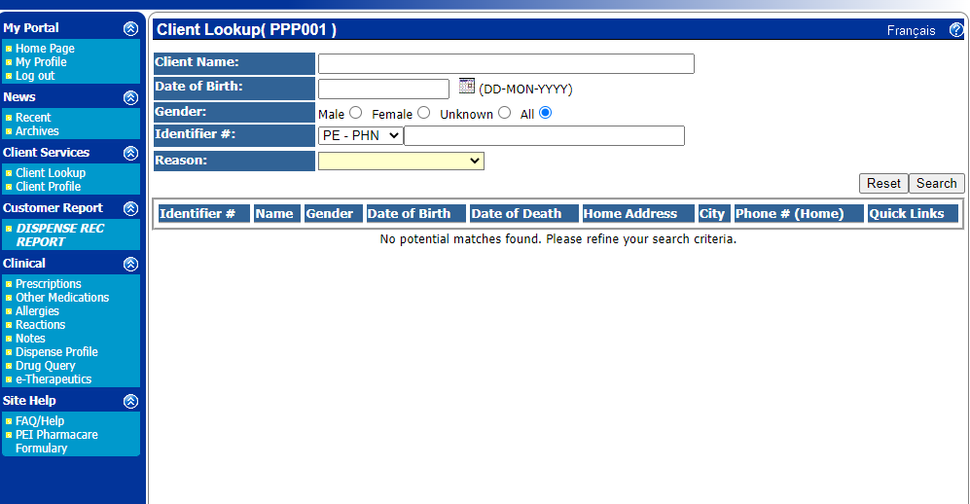

In order to change a password:
- Enter a new password into the “password” field
- Select “Password (confirm)”
- Select update
- Log out and log back in

