Safety Questions for Leadership Walkabouts
Being visible and discussing safety issues with staff is critical to building a culture of safety.

- What safety initiatives are happening here?
- What safety issues are you concerned about?
- Have there been any incidents lately where a patient was harmed?
- Have there been any near misses?
- Where can we make some safety improvements?
- What can I do to help?
- Ask a patient about their experience.

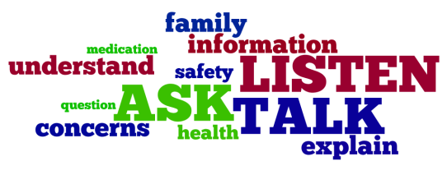
Follow-up and feedback on issues discussed is critical.

