Name: Department/Location: Date:

Score: /10

- WHMIS provides information to workers about hazardous materials through which of the following method(s)?

- Supplier & Workplace labels
- Safety Data Sheets
- Worker education & training
- All of the above

- Which of the following are potential effects of a health hazard? Select all that apply.

- Explosive
- Aspiration Hazard
- Respiratory or Skin Sensitization
- Flammable
- Carcinogenicity

- A simple asphyxiant hazard is defined as:

- A finely divided solid material that can catch fire or explode
- A substance or mixture that displaces oxygen in the atmosphere
- A gas that spontaneously ignites in the air
- A substance or chemical that poses acute toxicity

- A pyrophoric gas:

- Causes oxygen deprivation
- Causes skin corrosion or irritation
- Spontaneously ignites in air at or below 54 degrees Celsius
- Emit flammable substance when in contact with water

RATIONALE: Pyrophoric gases, solids, and liquids are all products that catch fire very quickly (spontaneously) if exposed to air. Pyrophoric gases, such as silane, are typically stored in compressed gas cylinders.

- Match the WHMIS 2015 hazard pictogram with the correct category below:
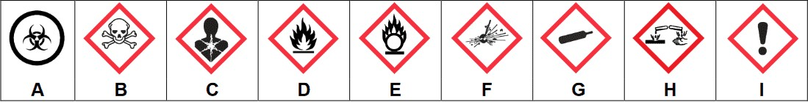

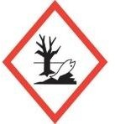
J

1. Flammables (gases, aerosols, liquids, solids); Pyrophoric (liquids, solids, gases); Self-reactive substances and fixtures; Self-heating substances and mixtures; Substances and mixtures which, in contact with water, emit flammable gases, organic peroxides

2 Oxidizing (liquids, solids, gases)

3 Gases under pressure

4 Carcinogenicity; Germ cell mutagenicity; respiratory sensitization; reproductive toxicity; Specific target organ toxicity–single exposure; Specific target organ toxicity–repeated exposure; Aspiration hazard

5 Corrosive to metals; Skin corrosion; Serious eye damage

6 Self-reactive substances and mixtures, Organic peroxides

7 Acute toxicity (oral, dermal, inhalation; fatal or toxic)

8 Acute toxicity (harmful); Skin irritation; Eye irritation; Skin sensitization; Specific target organ toxicity–single exposure (respiratory irritation or drowsiness or dizziness)

9 Biohazardous infectious materials

10 Environmental

RATIONALE: Pictograms are graphic images that immediately show the user of a hazardous product what type of hazard is present. With a quick glance, you can see, for example, that the product is flammable, or if it might be a health hazard. Pictograms will be on the product supplier labels of the hazardous products you work with. They will also be on the SDSs (as the symbol or words that describe the symbol).

- A signal word on a shipping label:

- Describes the nature of the hazards of the product
- Alerts the reader quickly to the severity of the chemical’s hazard
- Explains how to handle the chemical safely
- Is always accompanied with a pictogram

- Workplace labels are required when:

- Products are transferred from its original supplier container into another container
- The supplier label is missing or illegible
- The product is produced in the workplace
- All of the above

- A Safety Data Sheet (SDS) is available in the workplace to:

- Assist the purchasing department in buying chemicals
- Describe workplace policy
- Provide detailed hazard and safety information about a controlled product
- None of the above

- Which of the following SDS sections describes emergency procedures, protective equipment and how to contain and cleanup a spill or release?

- First Aid Measures
- Accidental Release Measures
- Handling and Storage
- Exposure Controls/Personal Protection

RATIONALE: Every product that is classified as a “hazardous product” under WHMIS that is intended for use, handling or storage in a workplace in Canada must have an SDS. Section 6, “Accidental Release Measures”, lists personal precautions, protective equipment, emergency procedures, and proper methods of containment and cleanup.

- If you are working with a chemical and need to find out about the routes of exposure, as well as the short- and long-term effects of exposure, where on the SDS would you look?

- Section 2: Hazard Identification
- Section 8: Exposure Controls / Personal Protection
- Section 11: Toxicological Information
- Section 16: Other Information

pg. 2

