Plan-Do-Study-Act (PDSA) Cycle Worksheet
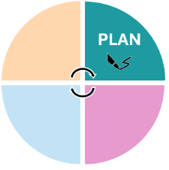
Team members:
Click or tap here to enter text.

Plan: A plan includes identifying what change will be tested and how.

Objective:
Click or tap here to enter text.
Who, what, where, when:
Click or tap here to enter text.
Plan for data collection:
Click or tap here to enter text.
Predictions:
Click or tap here to enter text.


Do: Put the plan into action.

Steps taken:
Click or tap here to enter text.
Data collected:
Click or tap here to enter text.
Observations and/or problems:
Click or tap here to enter text.
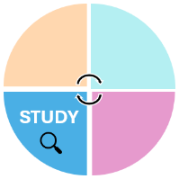
Study: Analyze the data collected.

Review and analysis of results:
Click or tap here to enter text.
Compare results to predictions:
Click or tap here to enter text.
What were the learning points:
Click or tap here to enter text.
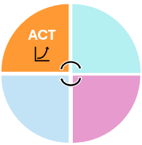

Act: Based on what you have learned, make plans for the next steps.

☐ Adapt? Click or tap here to enter text.
☐ Adopt? Click or tap here to enter text.
☐ Abandon? Click or tap here to enter text.

Date of completion: Click or tap here to enter text.
Plan to complete another PDSA cycle: ☐Yes ☐ No
If yes, repeat the cycle worksheet again. If not, outline your next steps:
Click or tap here to enter text.

